How to Complete the Animal Handler Questionnaire on UVM MyWellbeing (for enrolled students)

- Log in to mywellbeing.uvm.edu (not recommended for smartphone)
- Select Surveys & On-Demand Questionnaires from the left side menu
- Select “Animal Handler Questionnaire” from the On-demand Questionnaire section.
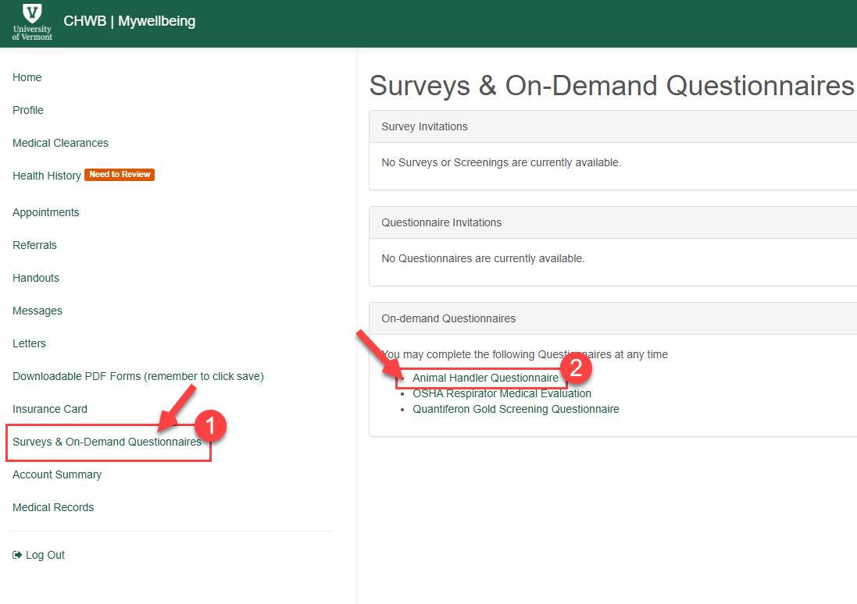
- Complete the form to participate in the Occupational Health Program. At the bottom of the form, click “I accept” and “Continue”.
- Student Health Services will either send an approval or a request for more information to your mywellbeing message folder. Please monitor your UVM email for message notifications or check UVM MyWellbeing for new messages. It may take Student Health Services 7-10 business days to review the questionnaire. Any questions should be directed to Student Health Services – (802) 656 3350.
- Once the clearance message appears in your UVM MyWellbeing portal, please email it to Risk Management and Safety at ohealth@uvm.edu. Please note you must email the approval message to ohealth@uvm.edu- you will not be approved to handle animals without completing this step. They will then notify the Research Protections Office of your clearance, which in turn gets updated in UVMClick.

